Dear Partners,

More destinations are with basic economic fare and I want to make sure you see the update see below that was sent to most of you today (March 28 2018 ) and the rest will be send tomorrow:

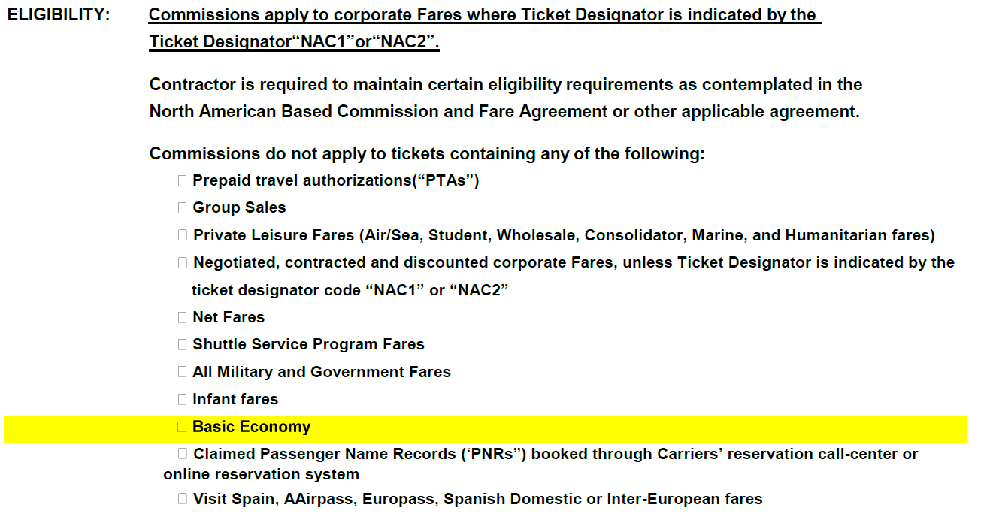

USUALLY BASIC ECONOMY IS CLASS B

FOR MORE INFORMATION ABOUT BASIC ECONOMY CLICK TO THIS LINK:

<https://aasaleslink.com/en-US/documents/Archives/AgencyRef/Basic_Economy_FAQ.pdf>

or

[www.aa.com/basiceconomy](http://www.aa.com/basiceconomy)

**From:** Russo, Varinia <[varinia.russo@aa.com](mailto:varinia.russo@aa.com)>   
**Sent:** Monday, April 2, 2018 12:25 PM  
**To:** Undisclosed recipients:  
**Subject:** Basic Economy

Dear Partners,

I want to give an example of the Basic Economic since is available in more markets and the class of services is B, however as you can see in the below example the fare basis can change but you will be able to know is basic economic because always end in **B3**

       BASE FARE                 TAXES/FEES/CHARGES    TOTAL

 1-    USD146.00                    145.91XT       USD291.91ADT

    XT     36.60US       5.65YC       7.00XY       3.96XA

            5.60AY      30.00UX      32.60VB      20.00AA

            4.50XF

          146.00                    145.91            291.91TTL

ADT-01  **ONN0AQB3** NNN4ACB1

 MIA AA SDQ35.00ONN0AQB3 AA MIA111.00NNN4ACB1 NUC146.00

 END ROE1.00 XFMIA4.5

**NONREF/NOCHG/NOCOBG/NOSEAT**

VALIDATING CARRIER SPECIFIED - AA

BAG ALLOWANCE     -MIASDQ-NIL/AA

1STCHECKED BAG FEE-MIASDQ-USD25.00/AA/UP TO 50 POUNDS/23 KILOGR

AMS AND UP TO 62 LINEAR INCHES/158 LINEAR CENTIMETERS

2NDCHECKED BAG FEE-MIASDQ-USD40.00/AA/UP TO 50 POUNDS/23 KILOGR

AMS AND UP TO 62 LINEAR INCHES/158 LINEAR CENTIMETERS

*IA«

 1   1511B 21APR J MIASDQ SS1   750P 1010P /E

 2   1154B 27APR F SDQMIA SS1   615A  850A /E