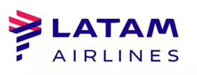

Below you will find the details of our new tour code for the Special Commission exception from BR-MIA.

Tour Code: 8000221
Total commission: 10%
Route northbound: BR - MIA (round trip)
Ticketing: January 01, 2021 - March 31, 2021
Travel dates: January 01, 2021 Until September 30th, 2021

Please Note: This tour code can't be applied for bundles Basic (QP) and Light (SL) in classes of service Q, O, A, G.
You can identify the bundle by the fourth and fifth character on the farebasis (ex. GLESLD8R)

Thank you for your partnership and continued support.

