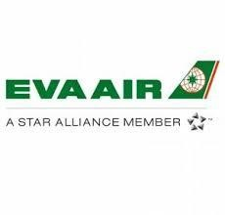
TOUR CODE = FNA-092
Valid for tickets issued – January 1, 2020 through December 31, 2020
Valid for travel January 1, 2020 through June 30, 2021 (based on outbound transpacific flight date)

Applicable Routing: USA/CA (to) TPE/S.E. Asia/N.E. Asia/China/BNE
*Valid on BR/B7 on-line (operating) service flights
*One-Way or Round-Trip or Open-Jaw permitted
**Commission Chart applies to BR through fare only (excludes all code-share flights) – also read Note and Note2

NOTE: Asia origins to USA – valid on BR/B7 – EVA Air still pays 3% standard commission to any ARC accredited agency. NO TOUR CODE required. This is NOT part of CCRA’s agreement.

NOTE 2: Please scroll down below the RULES for samples of itineraries that do not contain BR through fares and the commissions associated with them

Class of Service | Fare Basis | Booking Class Code | Commission
Royal Laurel Class (Mileage Fare) | COU/CU/CON/CN | C | 25%
Royal Laurel Class (Routing Fare) | C- | C
Royal Laurel Class | J- | J | 15%
 | D- | D | 10%
Premium Economy Class | K- | K | 15%
 | L- | L | 15%
 | T- | T | 15%
 | P- | P | 8%
Economy Class | Y- | Y | 15%
 | B- | B | 8%
 | M- | M | 8%
 | H- | H | 8%
 | Q- | Q | 8%
 | S- | S | 8%
 | W- | W | 8%
 | V- | V | 8%
TERMS and CONDITIONS:
- Valid for tickets issued January 1, 2020 through December 31, 2020
- Valid for travel between January 1, 2020 through June 30, 2021, based on outbound transpacific flight date
- Valid for tickets issued in the USA and Canada, no SOTO allowed
- Approval Code: FNA-092 (MUST be shown in “Tour Code Box”)
- Endorsement Box: “Non End/RRT”; “PE TRNSPAC” (for Premium Economy Class ticket only)
- One-Way Fare: Applicable for commission
- Child Fare: Applicable for commission (75% of adult fare)
- Infant Fare: Not applicable for commission chart above, Infant fare 10% of published fare with 5% commission 9. Refund/Reissue Charge: Normal rules apply; refer to your GDS
- Other rules:
  - This USA/CA – TPE/S.E. Asia/N.E. Asia/China/BNE commission applies to the applicable published fares listed above
  - All flights (except U.S./CA domestic portion) are valid on EVA on-line (operating) services only
  - U.S./CA domestic interline booking: refer to GDS for detail booking class code & routing. Domestic interline flights are commissionable if using a BR through fare
  - This commission is exclusively for CCRA Air participating agencies. These commissions can not be distributed via the internet or shared with anyone outside of your agency
  - These commissions can not be combined with any other EVA promotions
  - No SOTO; all travels must originate in U.S./CA only
  - Cross cabin sell and combine fare allowed; please refer to GDS
  - Agency may NOT claim additional commission
  - Other restrictions apply; please refer to GDS for detailed fare rules
  - Effective 05MAR19, No Show Fee applies; please refer to GDS for detailed fare rules
- If mixing fare basis types – for example, CON outbound with K2R return, calculate 25% outbound and 15% on return and claim the dollar amount of commission
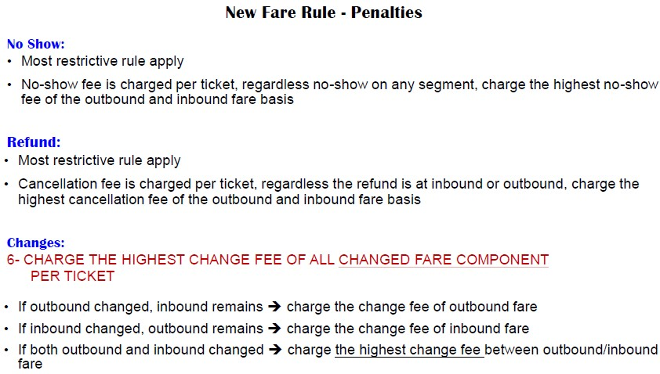

NON-Through Fare Commission samples, Effective May 1, 2019
Example 1:
ITINERARY: DFW-(AS)-LAX-(BR)-TPE-(BR)-BKK-(BR)-TPE-(BR)-LAX-(AS)-DFW

The commission for below itinerary with sector fares:
3% for sector fare DFW-LAX-DFW with AS (LH7OXVMN/LH4OAVMN): ($228.84 + $228.84) x 3% 8% for BR through fare (BLXU): ($485+$485) x 8%
Commission applies to AS segments as long as the entire ticket is issued as one and validated on BR
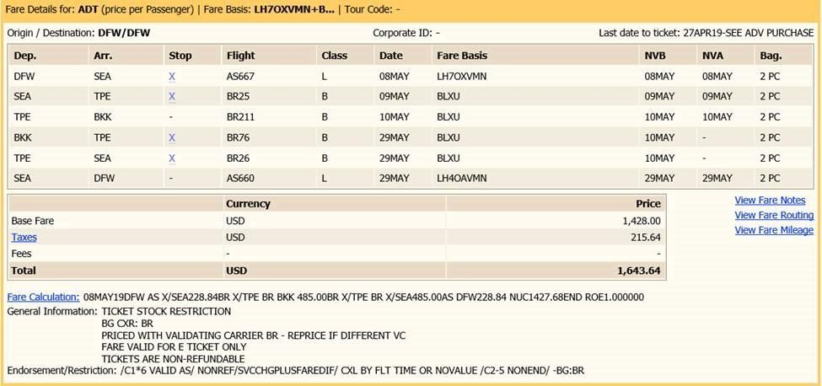

Example 2:
ITINERARY: DFW-(AS)-SEA-(BR)-TPE-(BR)-BKK-(BR)-TPE-(BR)-SEA-(AS)-DFW

The commission for below itinerary with through fare:
8% commission for through fare (BLXU): $1120 x 8%
Through Fare Example, so the main page of the agreement, commission chart applies
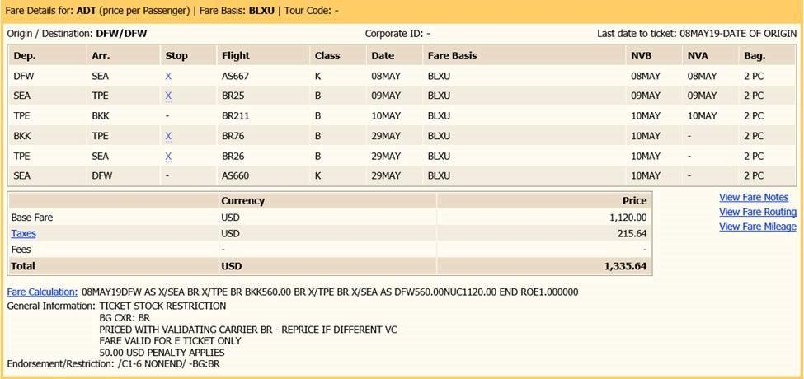
Example 3:
ITINERARY: LAX-(BR)-TPE-(BR)-BKK-(BR)-TPE-(BR)-LAX – not a through fare but all space on BR

The commission for below itinerary with fare breaks in TPE:
8% commission for BR through fare (LAX-TPE-LAX): ($2585 + $2585) x 8%
3% commission for sector fares (TPE-BKK-TPE): ($587.91 + $518.25) x 3%
